**Digital Design and Computer Organization Laboratory**

**3rd Semester, Academic Year 2024**

Date: 24/10/2024

|  |  |  |
| --- | --- | --- |
| Name: Rithvik Rajesh Matta | SRN: PES2UG23CS485 | Section: H |

Week#____10_______ Program Number: ____10__

Aim of the Experiment:

CONSTRUCT A PROGRAM COUNTER, FOR EVERY CLOCK CYCLE.GENERATE THE VVP OUTPUT AND SIMULATION WAVEFORM USING GTKWAVE. VERIFY THE OUTPUT AND WAVEFORM WITH THE TRUTH TABLE

I. Verilog Code Screenshot

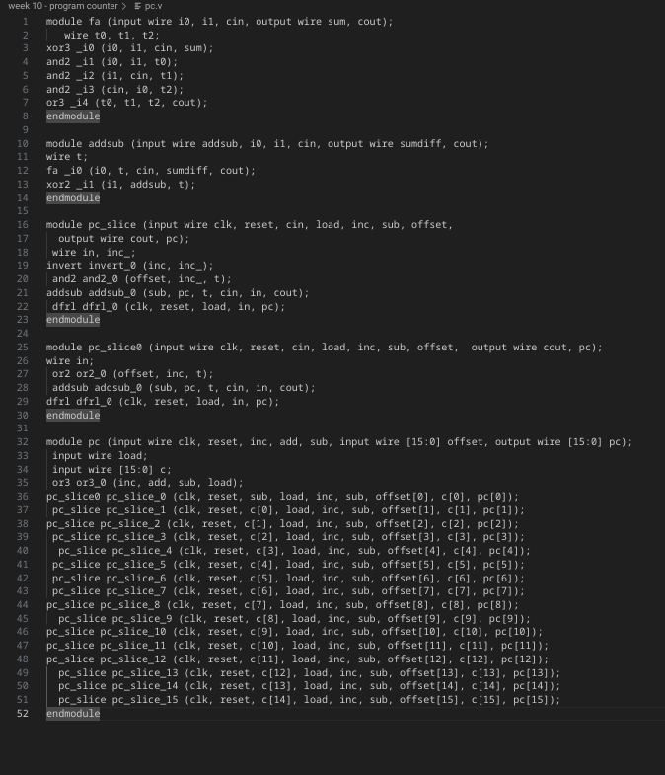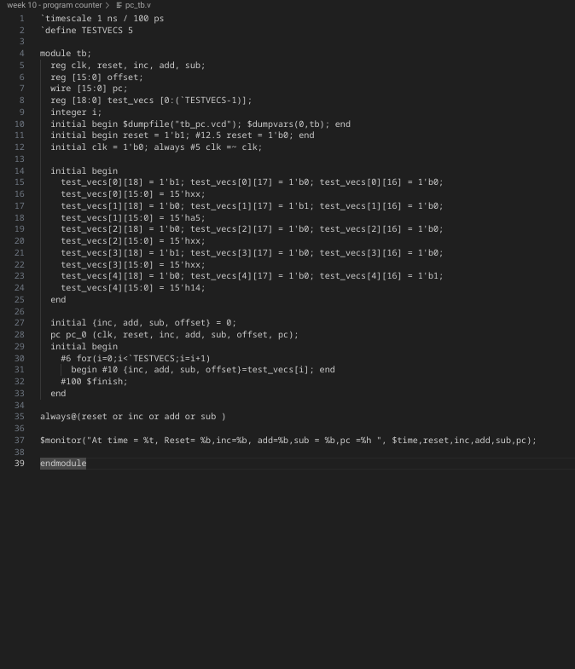

II. Verilog VVP Output Screen Shot

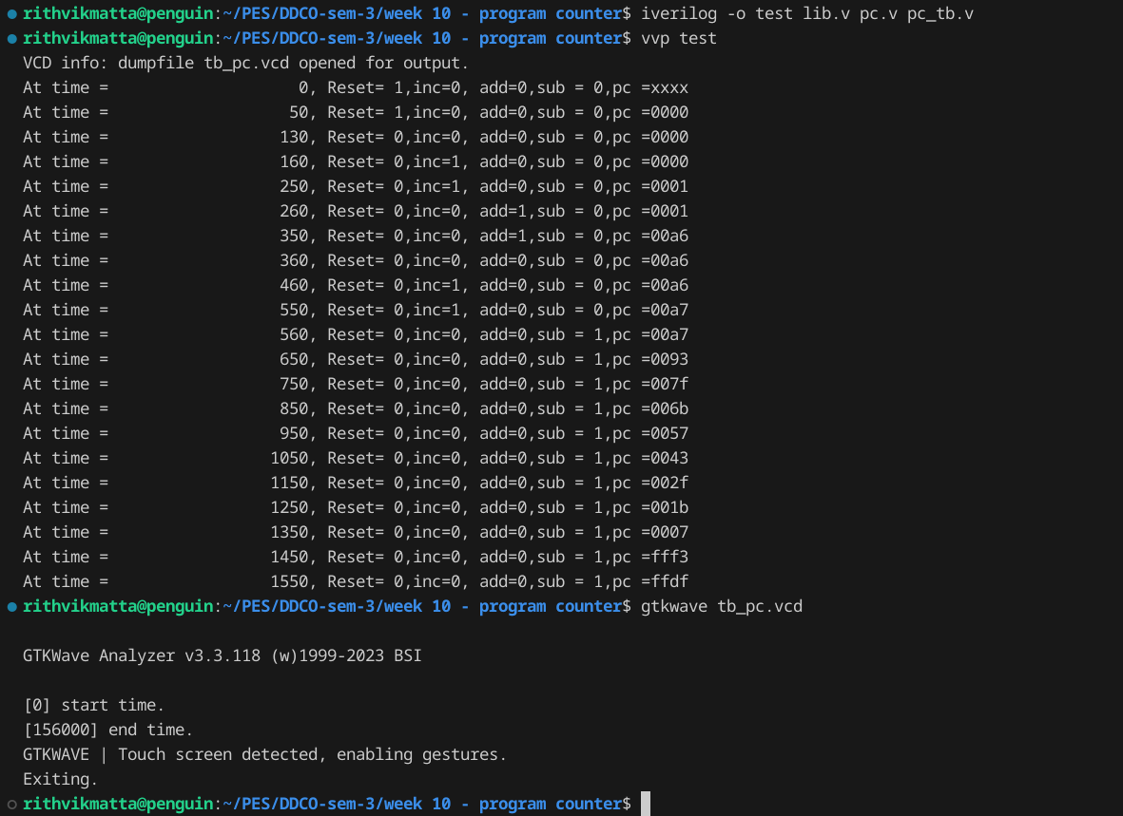

III. GTKWAVE Screenshot

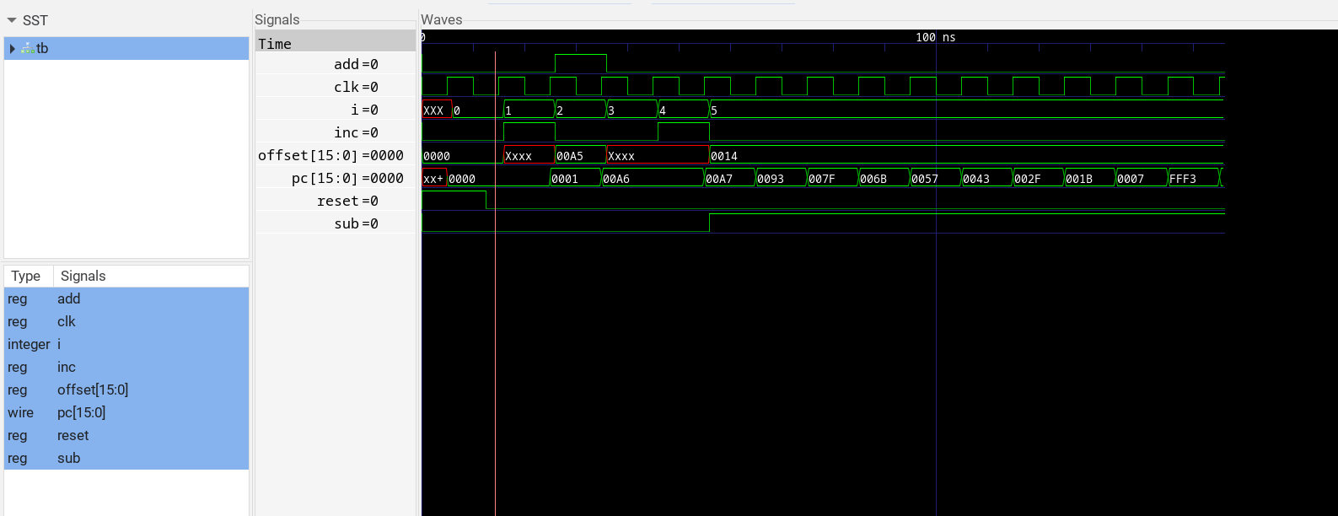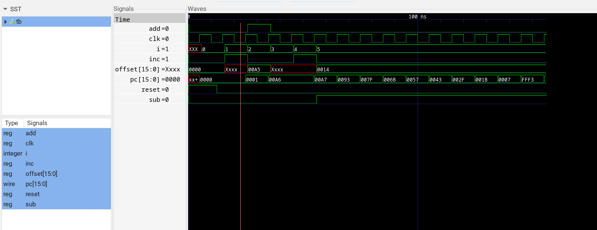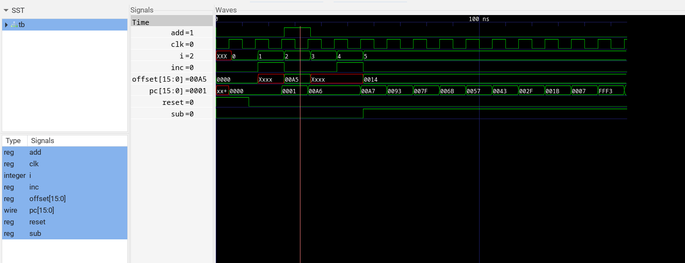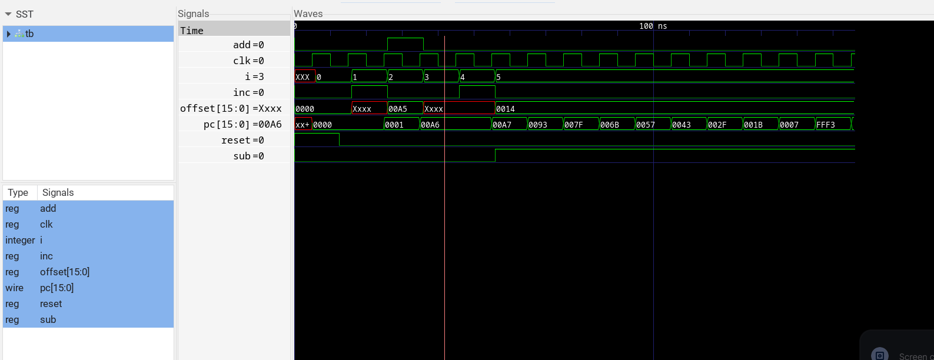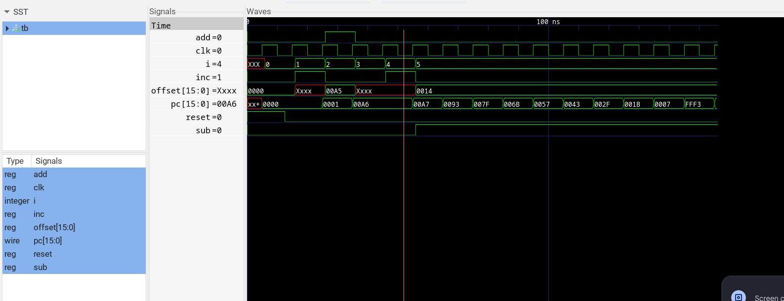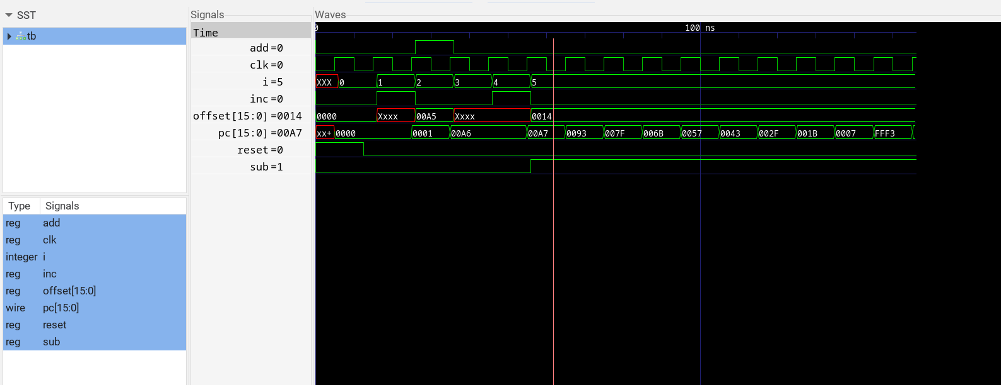

IV. Output Table (Truth Table)

|  |  |  |  |  |  |
| --- | --- | --- | --- | --- | --- |
| Time | Reset | Inc | Add | Sub | PC |
| 0 | 1 | 0 | 0 | 0 | xxxx |
| 50 | 1 | 0 | 0 | 0 | 0000 |
| 130 | 0 | 0 | 0 | 0 | 0000 |
| 160 | 0 | 1 | 0 | 0 | 0000 |
| 250 | 0 | 1 | 0 | 0 | 0001 |
| 260 | 0 | 0 | 1 | 0 | 0001 |
| 350 | 0 | 0 | 1 | 0 | 00a6 |
| 360 | 0 | 0 | 0 | 0 | 00a6 |
| 460 | 0 | 1 | 0 | 0 | 00a6 |
| 550 | 0 | 1 | 0 | 0 | 00a7 |
| 560 | 0 | 0 | 0 | 1 | 00a7 |
| 650 | 0 | 0 | 0 | 1 | 0093 |
| 750 | 0 | 0 | 0 | 1 | 007f |
| 850 | 0 | 0 | 0 | 1 | 006b |
| 950 | 0 | 0 | 0 | 1 | 0057 |
| 1050 | 0 | 0 | 0 | 1 | 0043 |
| 1150 | 0 | 0 | 0 | 1 | 002f |
| 1250 | 0 | 0 | 0 | 1 | 001b |
| 1350 | 0 | 0 | 0 | 1 | 0007 |
| 1450 | 0 | 0 | 0 | 1 | fff3 |
| 1550 | 0 | 0 | 0 | 1 | ffdf |

If found plagiarized, I will abide with the disciplinary action of the University.

Signature:

Name: Rithvik Rajesh Matta

SRN: PES2UG23CS485

Section: H

Date: 24-10-2024